國立東華大學資訊工程系博士班資格考
程式語言與編譯器, 2007 Spring

- (10 pts) List three problems for the following grammar. How do you modify it to remove the problems?
<assign> →<id>:=<expr>
<id> →A|B|C
<expr> →<expr>+<expr>|<expr>*<expr>|(<expr>)|<id>

- (10 pts) According to the following grammar, decide whether the two strings “bbbaab” and “aaabba” are valid? Remember to draw the parse tree if the input is valid.
<S> → <A>a<B>b
<A> → <A>b ∣ b
<B> → a<B> ∣ a

- (10 pts) Describe the major features and application domains for each of the following languages?
  - COBOL
  - JAVA
  - C
  - SQL
  - HTML

- (20 pts) What do “static scoping” and “dynamic scoping” mean? For the following PASCAL-like program, what will be printed out if the two kinds of scoping rules are applied, respectively?

- (Analysis and Synthesis)
  - (5 points) What is the analysis part of a compiler? Name 3 major phases of a compiler that belong to the analysis part.
  - (5 points) What is the synthesis part of a compiler? Name 2 major phases of a compiler that belong to the synthesis part.

- (Lexical analysis)
  - (4 points) What is the major function of lexical analysis?
  - (6 points) Give the regular expressions that can recognize the following tokens.
    - WHILE, which consists of string “while”.
    - ID, of which the first character can be an English letter in big or small case, and each of the following characters can be an English letter in big or small case or a decimal digit.
    - NUM, which consists of one or more decimal digits.

- (Top-down Parsing)
  - (4 points) What is a top-down parsing?
  - (6 points) Give a sketch of a program that can parse the source code by a top-down parsing with the following grammar.
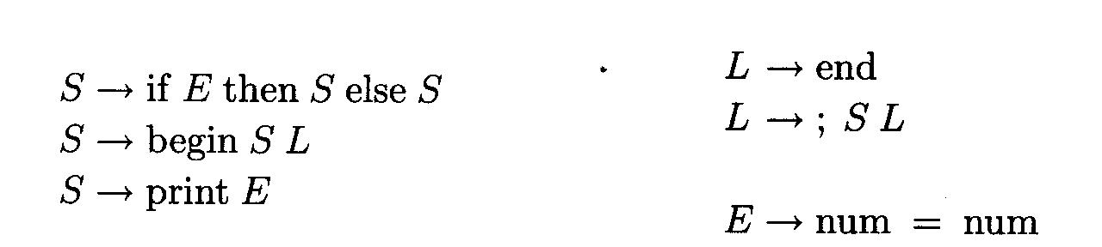

- (10 points, LR parsing)
Using the following grammar and parsing table, show each action taken in parsing “print( a+6 )”.
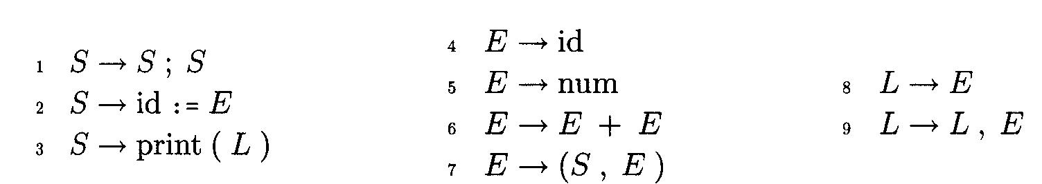
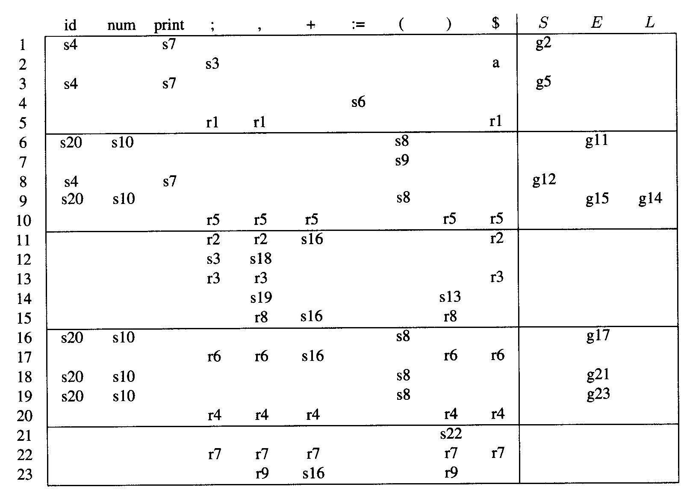

- (10 points, Parsing Table)
Consider a grammar G with the following grammar rules:
S → id | V := E
V → id
E → V | num
Construct an LR parsing table for G. Please tell the parsing table you construct is LR(0), SLR(1), LR(1), or LALR(1).

