國立東華大學資訊工程系博士班資格考
計算理論, 2006 Fall

- (20%) Is the language L = {ww | w ∈ {0,1}*} a regular language? Try to prove or disprove that L is a regular language.

- (20%) Describe a clear method that converts an NFA into a DFA. Use the following graph as an example to demonstrate how your method converts it into a DFA.
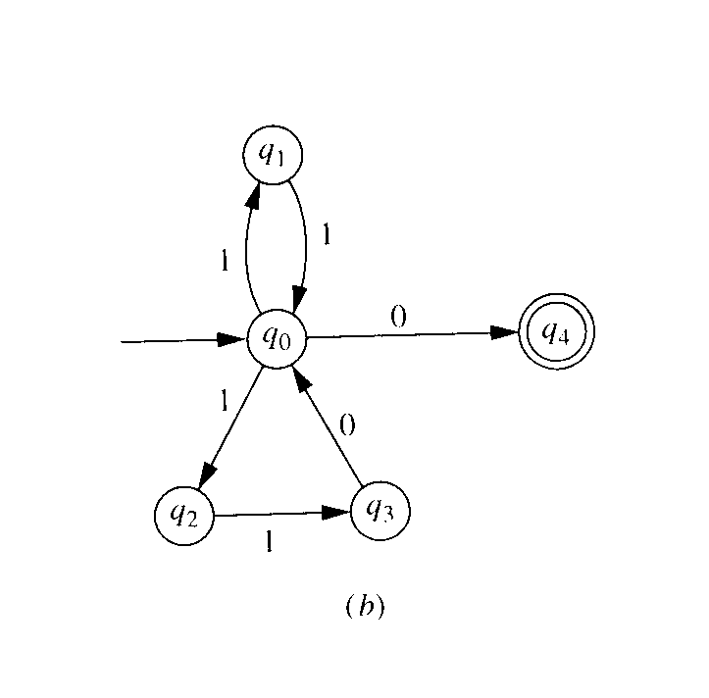

- (20%) Determine whether the following languages are context-free or not. If the language is context-free, give a context-free grammar to accept the language. If the language is not context-free, give a clear proof.
  - L₁ = { a^{n}b^{m}a^{m}b^{n} | m, n ≧ 0 }
  - L₂ = { a^{i}b^{j}c^{k} | i < j < k }

- (20%) What is the language generated by the following grammar G? Give a complete transition table and transition diagram for the pushdown automaton that accepts the language.
S → aSa | bSb | c

- (20%) Prove or disprove that if L₁ and L₂ are languages over Σ and L₂ is recursively enumerable and L₁ ≦ L₂, then L₁ is recursively enumerable.

