NDHU CSIE PhD Qualifying Exam
Computer Architecture - Spring 2013

- [15%] In the design of processors, please explain what is (a) single cycle implementation (b) multiple cycle implementation (b) microinstruction

- [20%] Given the bit pattern: 1010 1101 0001 0000 0000 0000 0000 0010. What does it represent, assuming that it is (a) an unsigned integer (b) a two’s complement integer (c) a MIPS instruction (d) IEEE 754 binary representation in single precision.
Instruction | Opcode (decimal)
andi | 12
ori | 13
lw | 35
sw | 43
beq | 4
bne | 5
j | 2

- [15%] Suppose you have a machine which executes a program consisting of 50% floating point multiply, 20% floating point divide, and the remaining 30% are from other instructions. You can make the divide run at most 3 times faster and the multiply run at most 8 times faster. What is the speedup of the improved machine relative to the original machine if you improve (a) only multiplication (b) only division (c) both multiplication and division?

- Pipeline architecture:
- [5%] There are five stages for the MIPS machine in the figure. Explain what is done in each stage, respectively.
- [4%] Which stages are used in the beq instruction, assuming this instruction cannot decide whether it will branch or not and where to go until the end of the 3rd cycle.
- [4%] Which stages are used in the sw (store word) instruction?
- [5%] There is a “Shift left 2” unit in the pipeline. What instructions need this unit? What is it used for?
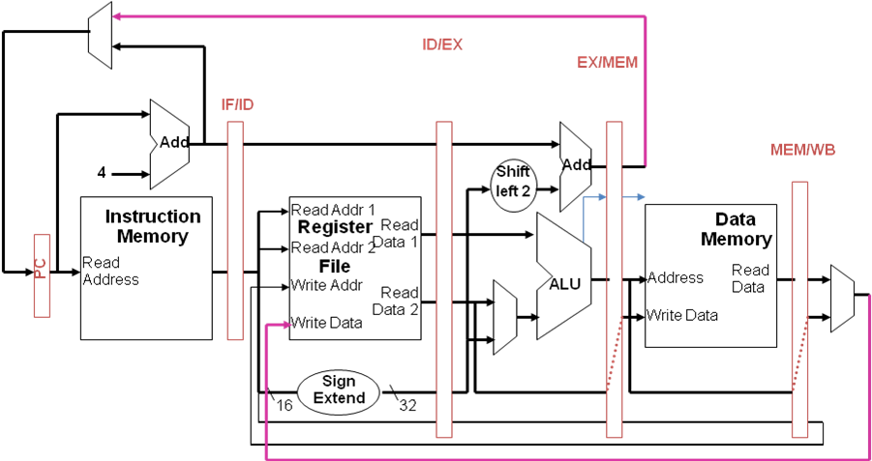

- Assume that the memory address of a computer system is 32 bits. The memory location is byte addressed. Suppose we use a direct mapped cache for this computer system. The widths in a 32-bit virtual address for byte offset (in a block), cache index, and cache tag are 7 bits, 12 bits, and 13 bits, respectively.
- [8%] How large is the address space? What size is a cache block? (Both in terms of bytes)
- [8%] What is the total size of the direct mapped cache?
- [8%] If we change the direct mapped cache to a fully associate cache, given the same amount of cache capacity, what are the widths for cache index and cache tag?
- [8%] If we change the direct mapped cache to a 4-way set associate cache, given the same amount of cache capacity, what are the widths for cache index and cache tag?

